ASSIGNMENT 6
Insert/Delete/Truncate/Drop

In this lab you will use SQL statements that fall in both the DDL and DML category. In this lab you will be storing new information in the database. You will be using the tables from your previous assignment as such: (Make sure that your tables contain the following columns along with the appropriate constraints

Student
SSN primary key
lname
fname
dob
salary check>10000
(lname and fname are a composite candidate key)

Class
Class code primary key
Class description (Create an index on this column using the create index command)

Student_class
SSN Foreign key
Class Code Foreign key
(SSN and class code are a composite primary key)

You must execute the statements in the order in which the questions are being asked.

Suggestions:
- Do not create a spool file. This lab will probably take several days. Since you cannot guarantee that the work that you did on my home computer or the lab computers on campus will be there the next time you open up the SQLPlus session, I would make the following suggestion: Store all your SQL statements in a text file. Then you can just copy and paste your SQL statements into the SQLPlus session and get back to where you left off.

- I would also suggest that you drop all your tables in the beginning of the text file just in case the tables are still there so that you don’t get any error messages

All the tables that you create should be prefixed with the first five letters of your lastname such as sabze_patient

What to turn in:
- You will turn in this word document only. I do not want any other files
- Paste a printscreen of either the SQLPlus session or SQL Developer showing only the SQL command and the results from the database engine. Some of the SQL statements that you issue may cause an error and may actually be the expected result. Do not assume that just because you are not getting an error message, everything is okay.
- When typing in your SQL statements, make sure that the keywords are all in uppercase. The identifiers that you come up with such as table names, column names or constraint names should all be in lower case.
- Make sure that you prefix your table names with the first five letters of your last name.
- Make sure that you only provide a printscreen of the snippet that pertains to the question (NOTHING MORE).

Suggestion: you can use the snipping tool in windows 7 or you can download this open source program http://getgreenshot.org/ for printscreens. Provide only the printscreen that pertains to the question. I do not want to see your trial and errors or things that pertain to other questions.

SQLPlus or SQLDeveloper (Your choice)
Example | Display the contents of the dual table
 | 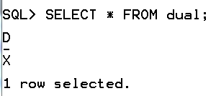 OR 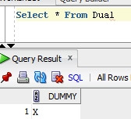
Next Example | Create a table called test
 | 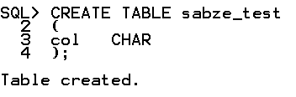 OR 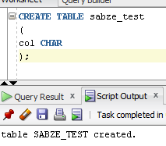

All the tables that you create must be prefixed with the first five letters of your last name such as sabze_student.

The order in which you insert data into your tables is different from the order in which the questions have been asked. Questions 1a, 1b and 1c should not give you any error messages
1A | Insert three rows of valid data into the student_class table
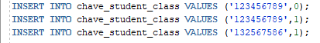
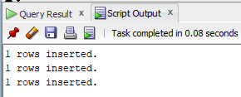

1B | Insert two rows of valid data into the class table according to the following. Make sure that you provide a value for every column.
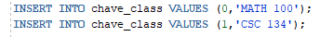
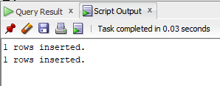
1C | Insert two rows of valid data into the student table according to the following. Provide a value for every column.  For the 1st row:  Use the to_date function to insert into the DOB column in the format (yyddmm)  For the 2nd row  Use the default date format (Do not use to_date function) (use default)
 | 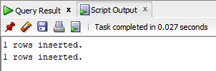

Do the questions in the order in which they appear. You may get error messages which of course is valid
2A | Insert a row of invalid data into student table such that it violates the primary key
 | 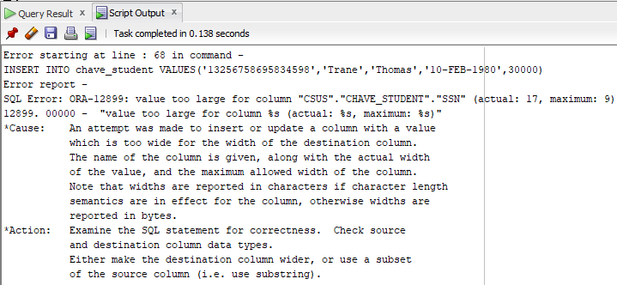
2B | Insert a row of invalid data into student table such that it violates the candidate key
 | 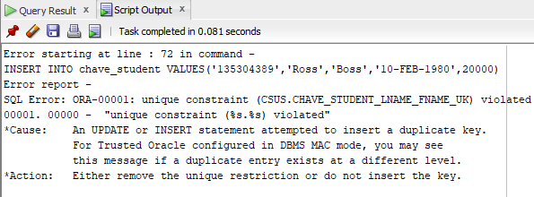
2C | Insert a row of invalid data into student table such that it violates a check constraint
 | 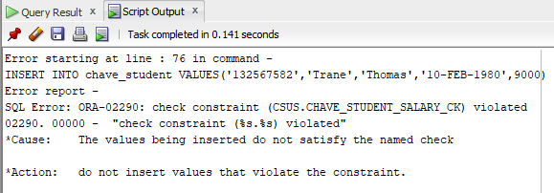
2D | Insert a row of invalid data into the student_class table such that it violates the foreign key to the class table
 | 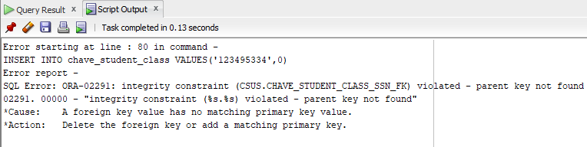
2E | Insert a row of invalid data into the student_class table such that it violates the foreign key to the student table
 | 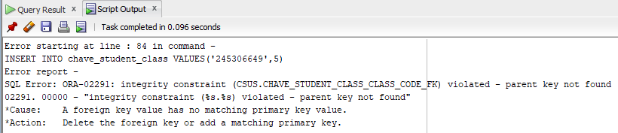
2F | Insert a row of invalid data into the student_class table such that it violates the primary key in the student_class table.
 | 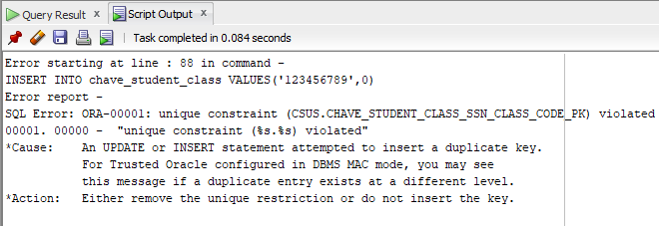

Do the questions in the order in which they appear.You may get error messages which of course is valid
3A | Disable the foreign key constraint to the student table
 | 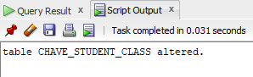
3B | Insert a rows of data into the student_class table such that it would violate the foreign key constraint if the above constraint to the student table was enabled
 | 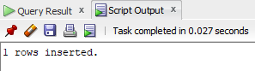
3C | Enable the foreign key constraint
 | 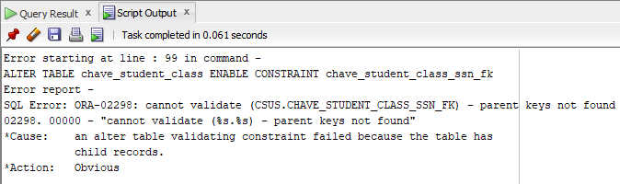

Do the questions in the order in which they appear. You may get error messages which of course is valid
4A | Delete the data from the student_class table
 | 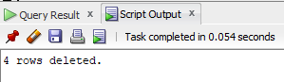
4B | Truncate the student table
 | 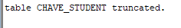
4C | drop the index that you created on the student table
 | 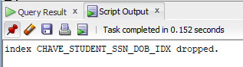
4D | Drop the foreign key constraints
 | 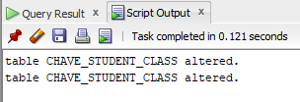
4E | Drop the student table.
 | 